February 16, 2020 Sixth Sunday After the Epiphany
********************************************************************
ORDER OF WORSHIP
The Call to Worship:
Make a joyful noise to the Lord, all the earth!
Serve the Lord with Gladness!
Come into His presence with singing
Know that the Lord, He is God!
It is He who made us, and we are His; we are His people,
And the sheep of His pasture.
Enter His gates with thanksgiving, and His courts with praise!
Give thanks to Him; bless His name!
For the Lord is good; His steadfast love endures forever,
And His faithfulness to all generations. – Psalm 100
Welcome into this House
The Songs of Worship & Praise
The Pastoral Prayer
The Affirmation of Faith (Apostles’ Creed)
I believe in God the Father Almighty, maker of heaven and earth; and in Jesus Christ his only Son our Lord: who was conceived by the Holy Spirit, born of the Virgin Mary, suffered under Pontius Pilate, was crucified, dead, and buried; the third day he rose from the dead; he ascended into heaven, and sitteth at the right of God the Father Almighty; from thence he shall come to judge the quick and the dead. I believe in the Holy Spirit, the holy Catholic Church, the communion of saints, the forgiveness of sins, the resurrection of the body, and the life everlasting. Amen
The Testimonies of the Saints
The Ministry of Music

The Black History Month Moment

The Offering Pastor Darryl A. Burton
(All things come of thee oh Lord, and of thy own, have we given thee, Amen)
The Ministry of Music
The Preached Word Rev. Kim E. Burton
Observation: ________________________________________________________________________________________________________________________________________________________________________________________________________________________
The Invitation to Discipleship
The Altar Call
The Pastoral Remarks
The Doxology
Praise God, from whom all blessings flow, Praise Him all creatures here below. Praise Him above, ye heavenly host, Praise Father, Son, and Holy Ghost.
The Benediction (Let the Church Say Amen)

Welcome!!!
On behalf of Pastor Darryl and Rev. Kim Burton, and the Converted Heart family, we gladly welcome you to our church home, trusting that you will experience the presence of God in our midst. We pray that you will find faithful companionship and Christian love here at Converted Heart.

We ask that all first-time guests please see Pastor Darryl immediately after worship service for a welcome packet and information on upcoming events.

C o n v e r t e d H e a r t
A Christian Methodist Episcopal Mission Congregation

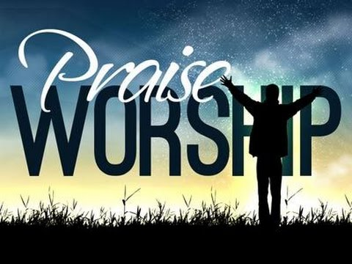

Reverend Darryl A. Burton Sr., Pastor
Reverend Kim E. Burton – Local Minister
Reverend Kevin J. Agee, Presiding Elder
Bishop James B. Walker, Presiding Prelate

